Wendy Shaw

1045 words

The 1914 Generation Artists

The 1914 Generation transformed the Westernizing artistic impulse of the late Ottoman era into the modernizing impulse of the Republic of Turkey, founded in 1923. Stylistically, it thus distinguishes itself from earlier generations—through its interest in Naturalism—and from later generations—through its disinterest in aesthetic Modernism. More than functioning cohesively, the artists historiographically grouped as the ‘1914 Generation’ came to prominence as a result of the onset of the First World War. Artists most often included within this category are Nazmi Ziya Güran (1881-1937), Mehmet Ruhi Arel (1880-1931), İbrahim Çallı (1882-1960), Hikmet Onat (1882-1977), Feyhaman Duran (1886-1970), Hüseyin Avni Lifij (1886-1927), and Namık İsmail (1890-1935). Although often excluded because of their lack of affiliation with the Istanbul Academy of Fine Arts, artists in conjunction with this category by virtue of their participation in the pivotal transition from Ottoman to Turkish national identity also include Şevket (Dağ; 1876- 1948): a teacher at the French-language Galatasaray Lycée; the military-trained artists Mehmet Sami Yetik (1878-1935), Mehmet Ali Laga (1878-1947) and Ali Sami Boyar (1880-1967); and the female artist Mihri Rasim/Müşfik (1886-1954).

A group portrait by Feyhaman executed in 1921 illustrates many characteristics of the 1914 Generation. Like the casual posture and outfits of the sitters, the work’s studied Realism and a muted palette reflect the internalization of European academic values and their seemingly effortless, Naturalistic execution, and direct observation complimenting calculated composition. The casual poses of the artists—from left to right Sami, İbrahim, Feyhaman, Şevket, and Hikmet—portray them as participants in an ongoing Westernizing modernization that shows no interest in establishing an oppositional aesthetic avant-garde such as that in Europe. Rather, these artists put forth a role for arts that engages not simply European traditions of academic Realism, but more importantly the function of art within a modern, urban bourgeois lifestyle. The prominence of İbrahim, sitting above the group, reflects his strong, often self-promoting personality that led to his later recognition as leader of this generation, often also called the ‘Çallı generation.’ Yet the very use of his last name, adopted in 1934 with the institution of surnames in the Republic of Turkey, underscores the anachronism of this apparent leadership, long after the execution of his and his colleagues’ best-known works.

Having studied independently, at the Istanbul Academy of Fine Arts, or at military and foreign schools that provided sufficient artistic education to indicate prowess, most artists of the 1914 Generation arrived in Paris and Germany between 1907 and 1910. Although as foreigners they were unable to study officially at the Ecole des Beaux Arts in Paris, the young Ottoman artists studied in the studios of major academic painters of the era and showed little interest in contemporary Modernist movements disturbing established artistic values in Europe. With the exception of Huseyin Avni, who incorporated Fauvist colour influences in his work, none of the 1914 generation showed any interest in the artistic avant-garde.

Rather than aiming to mimic the newest artistic trends of Europe, artists of this generation were deeply invested in the dynamic changes within the Ottoman Empire enabled by the Second Constitutional Revolution of 1909. Despite their distance, they joined the Society of Ottoman Painters, established in 1909, and wrote about art in Europe for its journal. Forced to return home in 1914 (with the exception of Mehmet Sami, who returned in 1912 to fight in the Balkan wars) due to the onset of war in Western Europe, Nazmi Ziya, Namik Ismail, Feyhaman, Hikmet, and Ibrahim quickly rose to prominence as they replaced the foreign teachers who had taught at the academy and had been expelled from the empire due to the war. The rest also promoted the spread of Western-style artistic production as they taught at military and modern high schools in Istanbul. Most notably, Mihri Müşfik, having studied independently in Rome and Paris since 1907, soon rose to the leadership of the new Academy of Fine Arts for Women. Including the earliest portrait of Mustafa Kemal and even a lost portrait of the pope, her work is dominated by sensitive portraits of friends and family which use a Realist style that underscores less the restriction of contemporary women’s sartorial practices than the extent to which women were able to express personal style through the dynamism of their diaphanous veils.

After their return, artists of this generation played a central role in promoting the arts through their establishment of and annual participation in the annual Galatasaray exhibitions that started in 1916. The Department of War commissioned an exhibit to travel abroad to Vienna and Berlin (where the department was unable to travel), where artists portrayed both battles and scenes of peace in order to present Turks in a more favourable and civilized light to their European allies.

As the first generation of artists engaged with the realistic depiction of casual scenes taken from everyday life—with a strong interest in Naturalism and without strong recourse to Western genre conventions—artists of the 1914 Generation were the first to challenge cultural conventions of gender segregation through the depiction of women, both clothed and nude. While Ibrahim’s depictions of women and men reflected modern notions of monogamous romantic love and Nazmi Guran depicted their prominent reflection of Modernization through their presence in the public sphere, Namik Ismail used nude studies of his wife to promote a Naturalistic approach to the human figure as the foundation of both artistic and cultural Modernization. Such work reflects the dominant interest of the artists of this era: not to participate within an aesthetic avant-garde such as that emerging in Europe, but to be part of a cultural revolution complimenting the dynamic transition between the Ottoman Empire and the Republic of Turkey.

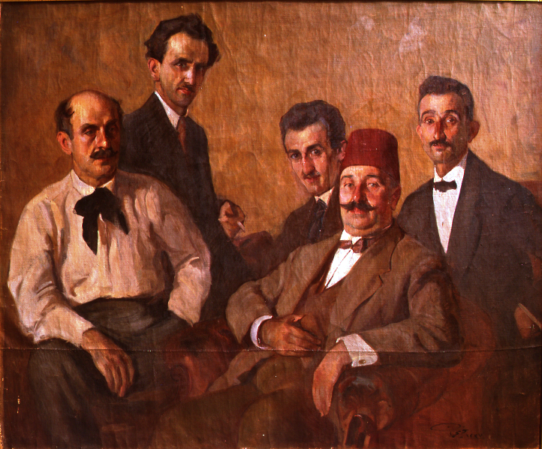

Feyhaman (Duran). *Group Portrait of Artists*. 1921. Oil on canvas, 133 x 162 cm. Mimar Sinan Güzel Sanatlar Üniversitesi (MSGSÜ) Istanbul Museum of Painting and Sculpture. (One applies directly to the university rectorate for permission these days, it seems.)

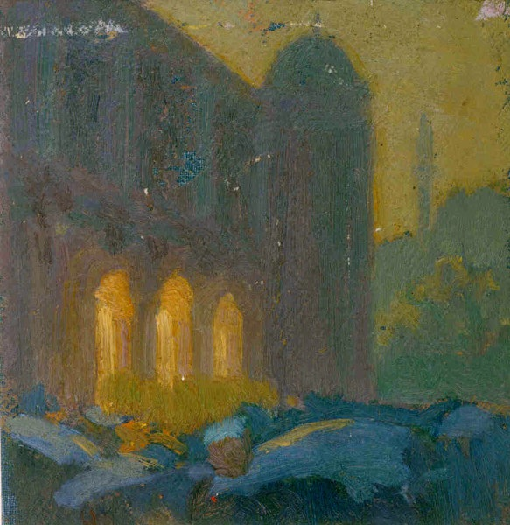

Hüseyin Avni Lifij. *The New Postoffıce at Sunset*. Oil on Canvas, 16.6 x 13.1 cm. Private collection, on website http://avnilifij.com/paint-115.html (most of these paintings are in the collection of the artist's family, and not difficult to get permission. If this painting doesn't work out, we can pick another).

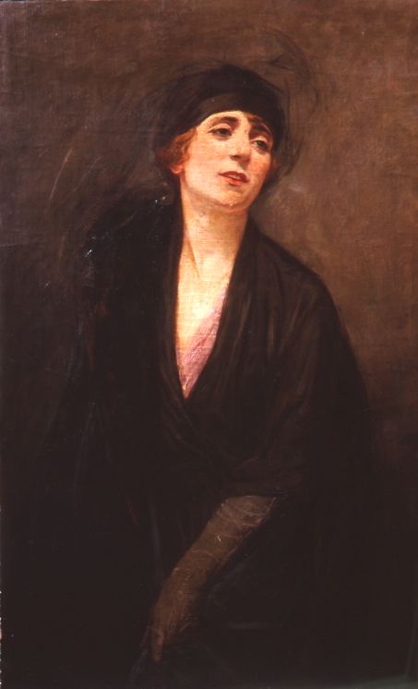

Mihri Müşfik. *Self-portrait.* n.d. Oil on canvas, 99 x 61 cm. MSGSÜ Istanbul Museum of Painting and Sculpture.

References and further reading:

Erol, Turan. *Nazmi Ziya*. Istanbul: Yapı Kredi Yayınları, 1995.

Giray, Kıymet. *Hikmet Onat*, İstanbul: Yapı Kredi Yayınları, 1995.

Giray, Kıymet. *Mahmud Cuda.* İstanbul: Türkiye İş Bankası, 2002.

Gören, Ahmet Kamil. *Türk Resim Sanatında Şişli Atölyesi ve Viyana Sergisi.* Istanbul: İstanbul Resim ve Heykel Müzeleri Derneği Yayını, 1997.

Özsezgin, Kaya. İbrahim Çallı. İstanbul: Yapı Kredi Yayınları, 1993.

Rona, Zeynep. *Namık İsmail*. İstanbul: Yapı Kredi Yayınları, 1992.

Shaw, Wendy M. K. *Ottoman Painting: Reflections of Western Art in the Ottoman Empire.* London: I. B. Tauris, 2011.

Shaw, Wendy M. K. “Where did the Women Go? Female Artists from the Ottoman Empire to the Early Years of the Turkish Republic,” *Journal of Women’s History* 13:1 (Spring, 2011) 13-37.

List of Works:

Hikmet (Onat). *Letter in the Trenches.* 1917. Oil on canvas, 145 x 120 cm. MSGSÜ Istanbul Museum of Painting and Sculpture.

İbrahim Çallı. *Lovers in a Boat,* Oil on Canvas, 150 x 182 cm. Suna and İnan Kıraç Collection (affiliated with the Pera Museum)

Nazmi Ziya (Güran). *Taksim Square*. 1935. Oil on canvas, 93 x 73 cm. Sabancı University (SU) Sakip Sabancı Museum.

Namık İsmail. *Nude.* 1917. Oil on canvas, 61 x 52 cm. Lucien Arkas Collection. (Try contacting Karoly Aliotti at aliotti@gmail.com)